Hat Trick
Razor Statement

Hat Trick is a 2D casual dungeon crawler where players fight their way through a magical castle hidden inside a magician's hat.

Measurements

The map is made up of tiles and as such characters and item size will be shown as # of tiles long x # of tiles wide. Speed will be shown as tiles per second (tps).

Characters

Benny
- The player controls Benny, a young magician who has been trapped inside
his own hat after his rabbits turned into monsters.
- Benny has 3 points of health.

Rabbits
- The rabbits have transformed into hideous monsters and can only return to their original form after Benny defeats them.
- A rabbit will appear for Benny to collect after defeating the mini boss of each level.
- The player will collect three of these rabbits to exit the castle and win the game.

Key enemy
- These enemies populate rooms in the castle.
- They have a powerful charge attack at 3 tps that deals 1 point of damage to Benny when it connects.
- They drop a key when they are defeated.
- Key enemies have 3 points of health.

Rabbit enemy
- Projectile
  - Fires every 2 seconds
  - Deals 1 point of damage.

- Charge attack
  - Speed of 4 tps
  - Deals 1 point of damage to Benny when it connects.
- Rabbit enemies transform from monsters back into rabbits after being defeated.
- Rabbit enemies are found in only one room per level.
- 10 points of health.

Mechanics

Movement
- Benny moves forward, backwards, left, right, and diagonally at a speed of 2 tps.

Regular shot
- Benny’s default attack is a magic attack that does 1 damage.
- Projectile moves at a speed of 4 tps and is 1 tile x 1/2 tile.

Charged shot
- A more powerful shot that does 5 damage
- Requires 1 second charge up before use.
- The projectile is stationary and is 3 tiles x 1 tile.

Aiming
- Charging the attack roots Benny to the spot and will not move, instead a reticule is rotated to aim the shot.
- Benny moves again after firing the charged shot.

Overarching Level Structure

The player will start in a hub area and move toward the first level, which is the only door in the hub area that will be open. These levels are maze like structures where the player will find and collect all of the keys to enter the mini-boss’ chamber. After the player completes the level by finding all the keys and defeating that level’s rabbit monster, they will be pushed back to the hub world and the door to the second level will be open. This will be repeated until the player has collected all three rabbits. The player can then exit the hat and win the game.

Level Structure

Level 1:
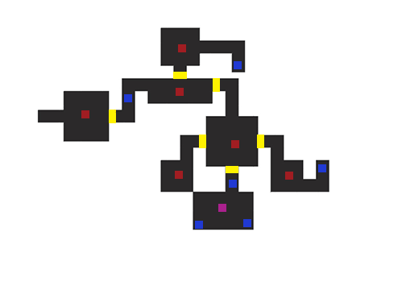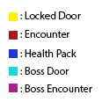
Level 2:
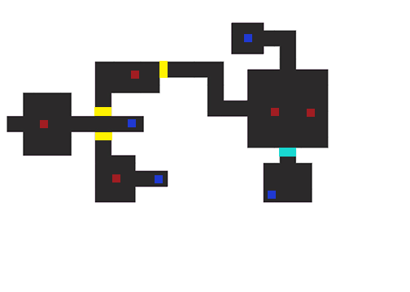

Level 3:
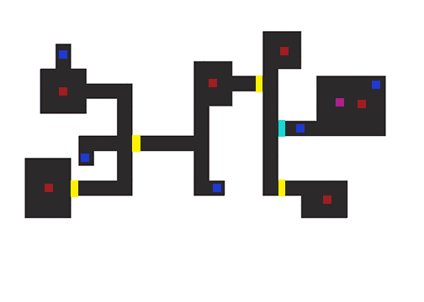
Macro Chart

 | Location | Level Structure | Unique  Gameplay | Required for level entry | Received in level
0 | Main Chamber | Top Down/2D
1 | Rabbit One  Chamber | Top Down/2D |  |  | Rabbit x1
2 | Rabbit Two Chamber | Top Down/2D | Enemy difficulty increases | Rabbit x1 | Rabbit x1
3 | Rabbit Three Chamber | Top Down/2D | Enemy difficulty increases | Rabbit x2 | Rabbit x1
4 | Game Exit |  | Win-Screen/  Credits | Rabbit x3

